Project plan

Big Chemistry

Big Chemistry
Eindhoven

Date : 02.03.2026
Version : 1
Status : Draft
Author : Miroslav Denkov

Version

Version | Date | Author(s) | Amendments | Status
1 | 02.03.2026 | Miroslav Denkov |  | Draft

Communication

Version | Date | To

Inhoudsopgave

1. Project Assignment 3
1.1 Context 3
1.2 Goal of the project 3
1.3 The assignment 3
1.4 Scope 3
1.5 Conditions 3
1.6 Finished products 3
1.7 Research questions 4
2. Approach and Planning 5
2.1 Approach 5
2.2 Research methods 5
2.3 Breakdown of the project 5
2.4 Time plan 5
3. Project organization 6
3.1 Team members 6
3.2 Communication 6
3.3 Test environment 6
3.4 Configuration management 6
4. Finance and Risks 7
4.1 Cost budget 7
4.2 Risks and fallback activities 7
5. Other 8

Project Assignment

Context

Fontys, along with many other universities all across the Netherlands, are working on “Big Chemistry” project. That entails the manifacturing of a fully self driving laboratory (SDL).

Goal of the project

Fontys, along with TU/e, are working on building a demonstrator, which invlovles sample preparation with a pipetting robot, sample transport with a robot arm and absorption measurements with a plate reader, all working under SILA2 standard. The final goal of the whole project is to create a fully autonamous chemistry laboratory environment to aid scientist in their research.

The assignment

The assignment consists in the continuation of a self-developed API protocol for controlling the Ufactory Lite 6 robot arm. The arm should be able to execute its tasks without making collisions with the other equipment in the lab. The arm must be able to walk through its trajectory unempeded. The demonstration includes the arm calibrateing itself and pick up the small plastic boxes, where the solutions would be placed. The Technologies involved are trajectory planning, inverse kinematics,Intermachine Communication. ROS2 framework, Python, Digital Twin

Functional Requirements:
- The arm must be able to position itself(calibration).
- The arm must NOT collide with surrounding equipment or itself(over-reaching).
- The arm must be able to find its trajectory.
- The arm must pick the small container up and put it on its destination.
Non-functional Requirements
- A conclusion towards tooling. Should the default tooling from Ufactory or ROS framework be used?
- Conclude if it is beneficial to use ROS2’s MoveIT library for trajectory planning(Part of ROS framework implementation experiments).
- Conclude what calibration implementation would be the most beneficial. QR-target-based or something else.
- Version control with Git.
- Research topics with DOT.

Scope

The project includes: | The project does not include:
- Research on ROS2 and similar technology | - Explicit development on SILA2
- Decision and consultation with backed-up evicence on which techonolgy is better-suited for the task at hand. | - Works on connecting the other equipment
- Implementation of path trajectory algorithm using either default tooling or ROS2 | - Works on connecting the other equipment
- Demonstration of the robotarm’s capabilities to safely deliver payload from point A to B. | - Works on connecting the other equipment

Moscow Table
Must | Should | Could | Won’t
The system must plan its trajectory | The system should have automatic positioning calibration |  | They system won’t support multi-arm coordination
The system must pick up payload and transport it

The system must be able to detect joint movement limit
The system must be able to stop in case of fault detection
The system must have reliable positional accuracy

Conditions
The company is under consideration on which technology to apply for the remainder of the project. The diversion in opinions is between the default tooling provided by Ufactory and it is up to the intern (me.) to experiment and reach a conclusion.

Finished products
Additionally the products to be presented are as follows:
- Research paper on the technologies mentioned earlier with a final conclusion drawn at the end.
- Demonstation on the capabilites of the Ufactory Lite 6 robot arm using the selected technology(video and live presentation format).
- Project plan.
- Portfolio.
- Git repository with source code and relevant documentation.

Research questions

Sub-question | DOT framework method
What are the benefits of using the standard toolkit provided by UFactory? | Library research:  Read through official documentations and compile deductions from multiple sources.  Lab research:  Design and execute scripts and monitor the development process on several factors such as; intuitivity, ease-of-use, skill-required, flexibility and control.  Field research:  Conducting interviews with co-workers and peers and documenting relevant findings.
What are the benefits of using ROS2? | Library research:  Read official documentation and compile information on the functionality and benefits of ROS2.  Field research:  Conduct interviews with co-workers and previous interns and collect opinions on the benefits of ROS2 (or its downsides)  Lab research:  Develop a small prototype and compare results with the default toolkit, across the several factors mentioned above; intuitivity, ease-of-use, skill-required, flexibility and control.
What is a trajectory-finding algorithm ? | Library research:  Read and research sources online (websites, libraries etc. ) for theoretical information.  Workshop research:  Prototype a path-finding algorithm for the arm, making sure to test both in simulation and on real hardware.  Lab research:  Test limits of the algorithm, as well as security testing (document findings on whether the arm can stop at joint limits, doesn't break external equipment and can orient itself well in 3D space. )
How to implement a trajectory-planning algorithm for the UFactory Lite 6 robot arm? | Library research:  Deep-dive into trajectory planning theory.  Field research:  Conduct an interview with a previous intern and acquire more information on what they produced during their time so that it would benefit the decision making factor.  Lab research:  Develop an effective trajectory-planning solution for the robot arm and test it by moving payloads between two positions.  Workshop research:  Develop a demonstration of the algorithm and present to associates to evaluate its effectiveness.

Approach and Planning

Approach

It is concluded that for this project the scrum method will be followed. On a personal and non-personal level. It is logical, since the company already implements it in their buisness with daily stand-ups. Below I have indicated approach elements and how I will be dealing with them.

Organization and planning
- Planning is done following the Canvas course and how the weeks are separated. For example:
Week 1-2: Project plan, meaning that the Project Plan must be done by the end of week 2.
Tracking
- Tracking tasks is done via a calendar agenda
Sprint set-up
- Each sprint will be around 2 weeks. By the end of each sprint the next one will be planned based on the context of the previous.
Stand-ups
- There are daily stand ups for the whole project arranged by the company. Additional meetings with indivduals will be arranged based on “need” basis. For example: Mentor meetings are arranged every Monday and Wednesday.
Retrospective and reflections
- Sprint retrospectives are done at the end of each sprint, concurrent with the planning of the next one.
- Reflections and feedback will be seeked from peers, assesor and company mentor either in written or spoken form(emails, teams messages or face-to-face meetings).

Test approach
Testing will be done using the following methods:
- Unit testing
- Simulation
During the course of the sprints, testing and experiments will be conducted when new features are done, to better determine compatability with previous code and/or remove bugs.

Research methods

The research method used for the project will be the DOT framework. Each main and subquestion will be researched based on that method. There are no specific restrictions when it comes to gathering necessary information.
I shall not outline each specific method since the each questions requires unique attention on what the best approach is. A common ground for each question would be the What and Why approach with the rest (Lab, Library) catering to specific sitations. The agile methods demands flexibility and to keep that I shall not limit myself to specific methods will be un-productive. Thus if I determine that a method would not fit the spicific case it will be removed. In my approach I want to keep flexibility to maximum as to be able to easily adapt and adjust to the current situation.

Learning outcomes
<<Discuss how you are going to demonstrate each learning outcome in the project. The easiest way is to think about which of the professional products you are going to use as evidence for each of the learning outcomes.>>.

The learning outcomes are as follows:

Professional Duties – I will fulfill this outcome by showing my work to my superiors during the internship and get feedback from them. In the end I would like to present my research, code and demo the functonality I’ve built.

Situation-orientation – I will apply all I have learned from my previous semester, such as: research with DOT framework, agile scrum management, SOLID coding standards and proactive attitude with active self reflection.

Professional Standard – I will demonstrate this learning outcome by meticulously and actively participate in day-to-day activities in the company. Diligently and responsibly researching and implementing ideas in parallel with advice from mentor and peers. Completing task in the agenda and keeping myself accountable will be the core of this learning outcome. Supporting documents will be created as the process goes on.

Personal Leadership – I will pay attention to my learning ability and seek improvement. Feedback from peers and superiors will be documented in feedpulses. Additional feedback documents, if needed, will be created to compile all the feedback received.

Learning outcome | Evidence
Professional Duties | Project Plan, Research document, Design sketches/documents, Git trail, source code snaphosts, Video and photo evidence,
Situation-orientation | Project plan, source code snapshots, task board, video evidence of work, Peer review trail, feedpulse trail
Professional Standard | Research document, Project Plan, Feedback trail, task board
Personal Leadership | Task board, Project plan, feedback trail

Breakdown of the project
Phase 1: Familiarization with the default tool-set. Testing the capabilites of the hardware. Running custom scripts for testing.

Phase 2: Research and implementation of ROS2 framework. Testing custom instructions and comparison with the default toolset.
Phase 3: Research on path-finding algorithm on default tool-set and ROS2. Comparison and final choice for technology framework with backed-up research and evidence.
Phase 4: Finalizing a demo and compiling all concurrent research documents, ready to be presented to faculty.

I will make use of the Scrum method and work on each of the phases in sprints. Issues will be divided according to the table:
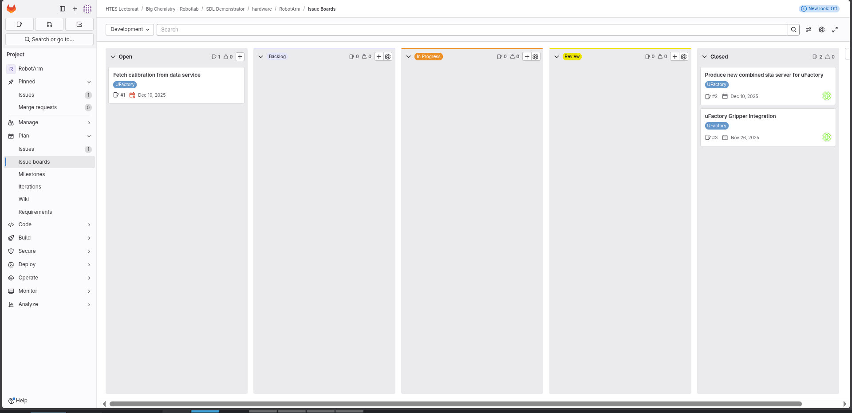
Closed issues will be saved in the backlog and issues will be closed after review or testing. Each issue will have a tag representing Sprint( sprint 1, sprint 2 etc.).

Time plan
Phasing | Effort | Start | Ready
- Familiarization phase | minimal-middling | 4th March | 25th-31st March
- Research and implementation (ROS and UFactory tool-set) | significant | 1th April | 15th-25th April
- Research and implementation on path-finding algorithms and orientation(ROS and Ufactory tool-set). | significant | 26th April | 25th May
- Finalization and reflection phase | middling | 26th May | 16th June

* Dates are just for orientation and are subject to change
*Because of agile methodology, being at a different phase does not mean the previous will never be touched upon again, ever.

Each phase’s sprints should last up to 2 weeks.

Project Organization

Team members

Name + Phone + e-mail | Abbr. | Role/tasks | Availability
j.geurts@fontys.nl, 06 53183066 |  | Company mentor, Educator | 4 days a week

Communication

Majority of the communication between supervisors are using the Teams platform. Additionaly, regular meetings with mentor and assesor are planned on weekly basis, and are face-to-face at minumum once a week.

Configuration management
The GIT structure will follow the already established. A branch will be created that, which in turn, may branch out to others as features are introduced. This is done to ensure safety and to keep the code-base clean.

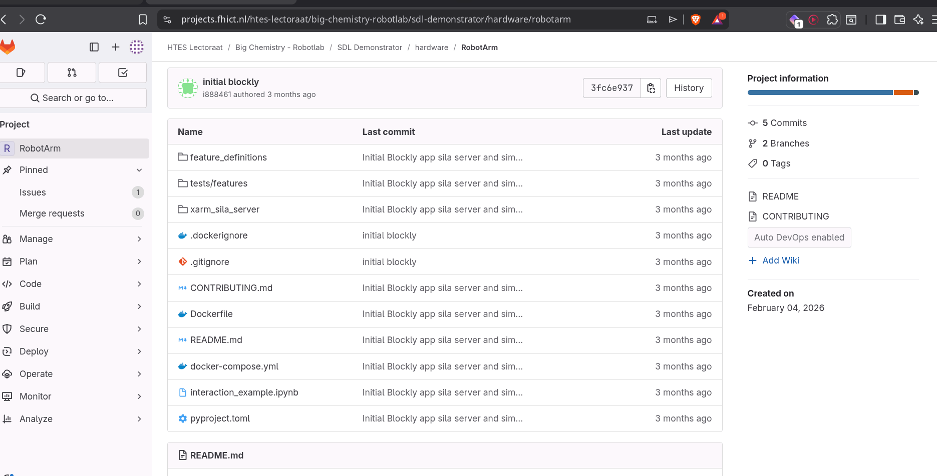

Finance and Risks

Cost budget
No extra costs are incurred for this project.

Risks and fall-back activities

Risks are minimal for this project, since by default, a lot of safeguards are implemented, both in hardware and software, any risks listed are unlikely to happen, but are listed just as a precaution

Risk | Prevention activities included in plan | Fall-back Activities
- Hardware failure | Careful operation of the systems. | Relying on simulations for the time-being.
- Software brick | Usage of recommended tools by Ufactory. | Relying on simulations

